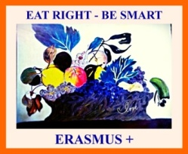
EAT RIGHT, BE SMART !
Mănâncă sănătos, fii deștept!
2015-1-SE01-KA219-012274_5
Lesson Plan
Teacher :Dragotă Teodora
School:C.N. T. Vladimirescu,Tg-Jiu
Date:March,28th
Grade:6 thB
Time:50 minutes
Title of the Lesson:Food,Glorious food
Aims:-to improve vocabulary on food words (food idioms)
-to revise the previous knowledge
-to develop communication skills
-to use new phrases in new contexts

Procedure:
Activity 1: Students` presentation of their homework and revision of the previous knowledge
(10 minutes)

Activity 2:Teacher announces the title of the new chapter: Food,glorious food!
Teachers elicits phrases about food (5 minutes)
Teachers announces the activity about food idioms
Worksheets are distributed to students and they can work in pairs to find the correct form of the idioms(10 minutes)

Activity3:Teacher checks students`answers with the help of the powerpoint presentations.
Students are asked to use the idioms in new sentences and homework is assigned (10minutes)
Activity 4:Write a short story using food idioms (10 minutes)
Activity 5.Feedback from students (5 minutes)
Homework:Find other 5 food idioms and make up a story using them.

EAT RIGHT, BE SMART !
2015-1-SE01-KA219-012274_5
Food idioms:
Find the correct place of the words represented in the pictures.Write the words in the spaces provided:
1.Be like two…………….……in a pod . 
(To be similar)
2.Go……………………………… . (get angry) 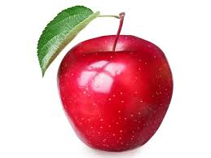

3.A hard ……………………….…..to crack 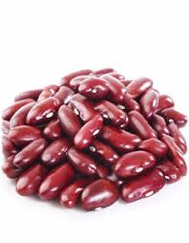
( a difficult person or thing to deal with or get to know)
4.Have bigger …………………………….… to fry 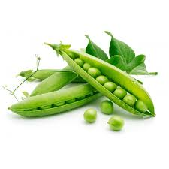
(to have more important things to do)
5.A couch……………………………………………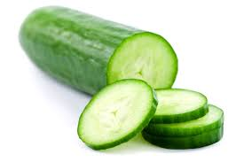
(someone who just sits on a coach and watches TV)
6.A big ……………………………….….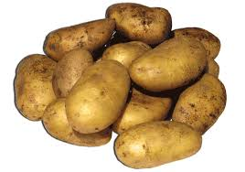
(a VIP)
7.The ............................of one`s eye 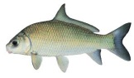
(a person that is adored by someone)
- 8. Full of....................................... 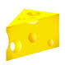
(very energetic)
9.as cool as a……………………………………..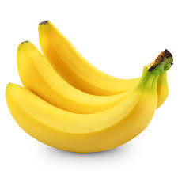
(very calm)
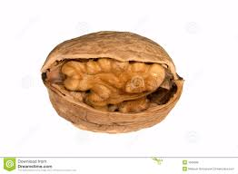
10. icing on the……………………………………
( something that makes a good situation or activity even better)

Fill in the missing food idioms:

1.The little girl is her grandfather`s favourite. She is ……………………………………
2.I found a good job and the fact that I can work where I want is ………………………….
3.My aunt is ………………………..….tonight and she does not want to stop talking.
4.The girl ……………………………when her boyfriend forgot to buy her a birthday present.
5.The sisters are like ………………………………….and they do everything together.
6.My friend is a very serious person and is a………………………………………………...
7.The man is …………………………………………….and never worries about anything.
8.My uncle is a ………………….........in his company so you should be very nice to him.
9.My cousin is a ………………………………….and he never wants to leave his house.
10.I have ……………………and I do not want to do extra work for my company.

KEY-Food idioms:
1.Be like two……………in a pod .
(To be similar)
2.Go……………………………… . (get angry)

3.A hard ……………………….…..to crack
( a difficult person or thing to deal with or get to know)

4.Have bigger …………………………….… to fry
(to have more important things to do)
5.A couch……………………………………………
(someone who just sits on a coach and watches TV)
6.A big cheese……………………………….….
(a VIP)
7.The ............................of one`s eye
(a person that is adored by someone)
- 8. Full of.......................................
(very energetic)
9.as cool as a……………………………………..
(very calm)

10. icing on the…………………………………………
( something that makes a good situation or activity even better)

1.The little girl is the apple of her grandfather`s eye.
2.I found a good job and the fact that I can work where I want is the icing on the cake.
3.My aunt is full of beans tonight and she does not want to stop talking
4.The girl went bananas when her boyfriend forgot to buy her a birthday present.
5.The sisters are like two peas in a pod and they do everything together.
6.My friend is a very serious person and is a very hard nut to crack.
7.The man is as cool as a cucumber and never worries about anything.
8.My uncle is a big cheese in his company so you should be very nice to him.
9.My cousin is a couch potato and he never wants to leave his house.
10.I have bigger fish to fry and I do not want to do extra work for my company.

